**Metaprogrammation impact**

Lately, R meta programmation seems to be in vogue. Very huge promises, encompassing  
code to produce code, variable indirection naming schemes, and many others marvelous  
features are now available through the **tidyverse**. Indeed, very huge promises,  
are generally the right sensor to enter into skepticism and to verify by our-self  
it worth or not to switch from well-known and limited code approaches, to less-known more  
promising and more modern code approaches

**A simple use case**

To start small, I just used meta programmation for a very simple case, that is  
access to data embedded into a **data.table**, using various variable kind of  
parameters.

Two main requirements are

1. parameter number is not known in advanced,
2. parameter might be given as **string** or **symbol**.

**Implementation**

**First approach: rely solely on data.table capabilities, using strings**

filter_by_string_builtin <- function(dt, ...) {

dt[, ..., with = FALSE]

}

Here, the limit is that you can not pass symbols in the call. You must use **strings**.

**Second approach: rely solely on data.table capabilities, using symbols**

filter_by_symbol_builtin <- function(dt, ...) {

dt[, ...]

}

Here, the limit is that you can pass only symbols in the call. You must not use **strings**.

**Third approach: use data.table capabilities and meta-programmation**

filter_by_symbol <- function(dt, ...) {

sy <- ensyms(...)

ss <- sapply(sy, as_string)

dt[, ss, with = FALSE]

}

Here you may use **strings** or **symbols**, or even mix them.

**Fourth approach: use tidyverse**

filter_by_quosure <- function(dt, ...) {

sy <- enquos(...)

#if (length(sy) == 0) return(dt)

dt %>%

select(!!!sy)

}

Here you may use **strings** or **symbols**, or even mix them.

**Run it by hand**

All of them provide right (from a functional point of view) and identical answer.  
OK, but what about performance ?

mm <- microbenchmark(filter_by_string_builtin(dt, 'x', 'r'),

filter_by_symbol_builtin(dt, x, r),

filter_by_symbol(dt, 'x', 'r'),

filter_by_symbol(dt, x, r),

filter_by_quosure(dt, 'x', 'r'),

filter_by_quosure(dt, x, r),

times = 1000

)

dz <- summary(mm)

dk <- as.data.table(tidyr::gather(dz, what, data, min:max))

dk[, `:=`(x = rep(1:6, 6), what = factor(what, levels = unique(dk$what), ordered = TRUE))]

g <- ggplot(dk, aes(x = what, y = data, group = expr, color = expr)) +

geom_line(size = 2) +

ggtitle(paste0('Microbenchmark - 6 number timing (', dk[1]$neval, ' evaluations)')) +

theme(legend.position = 'top')

h <- ggplot(dk[what != 'max'], aes(x = what, y = data, group = expr, color = expr)) +

geom_line(size = 2) +

ggtitle(paste0('Microbenchmark - 5 number timing (', dk[1]$neval, ' evaluations)')) +

theme(legend.position = 'top')

sf <- function(e) e / e[1]

dk[, `:=`(p = sf(data)), by = 'what']

p <- ggplot(dk[what != 'max'], aes(x = what, y = p, group = expr, color = expr)) +

geom_line(size = 2) +

ggtitle(paste0('Microbenchmark - 5 number timing ratio (', dk[1]$neval, ' evaluations)')) +

ylab('ratio in comparison to best performing approach') + xlab('') +

theme(legend.position = 'top')

And performance data are

Unit: microseconds

expr min lq mean median uq max neval

filter_by_string_builtin(dt, "x", "r") 111.1 128.20 154.0355 141.90 158.95 978.2 1000

filter_by_symbol_builtin(dt, x, r) 314.2 342.50 395.2979 360.40 392.30 8550.7 1000

filter_by_symbol(dt, "x", "r") 258.8 282.00 324.2122 295.70 324.55 3856.1 1000

filter_by_symbol(dt, x, r) 252.4 274.10 318.1286 285.90 309.30 3847.1 1000

filter_by_quosure(dt, "x", "r") 953.8 1023.80 1149.2981 1055.25 1107.05 4817.4 1000

filter_by_quosure(dt, x, r) 922.6 995.25 1118.5169 1024.50 1074.30 4728.6 10003

Some graphs to ease comparisons

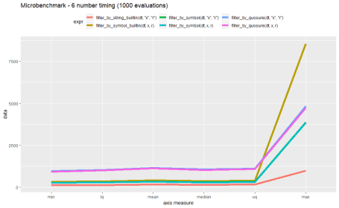

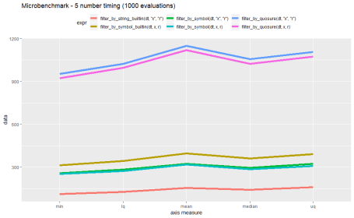

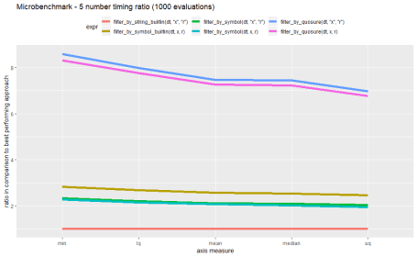

**Test context**

All tests are executed disconnected from any network, on the same machine, at the same time.  
More information below, about hardware used, capabilities, and software versions used.

$session

R version 3.5.2 (2018-12-20)

Platform: x86_64-w64-mingw32/x64 (64-bit)

Running under: Windows >= 8 x64 (build 9200)

Matrix products: default

locale:

[1] LC_COLLATE=French_France.1252 LC_CTYPE=French_France.1252 LC_MONETARY=French_France.1252

[4] LC_NUMERIC=C LC_TIME=French_France.1252

attached base packages:

[1] stats graphics grDevices utils datasets methods base

other attached packages:

[1] ggplot2_3.1.0 microbenchmark_1.4-6 dplyr_0.7.8 lobstr_1.0.1 Rcpp_1.0.0

[6] crayon_1.3.4 rlang_0.3.1 purrr_0.2.5 data.table_1.11.8 lubridate_1.7.4

[11] stringr_1.3.1

loaded via a namespace (and not attached):

[1] pillar_1.3.1 compiler_3.5.2 plyr_1.8.4 bindr_0.1.1 tools_3.5.2 digest_0.6.18

[7] evaluate_0.12 tibble_2.0.1 gtable_0.2.0 pkgconfig_2.0.2 rstudioapi_0.9.0 yaml_2.2.0

[13] xfun_0.4 bindrcpp_0.2.2 knitr_1.21 withr_2.1.2 grid_3.5.2 tidyselect_0.2.5

[19] glue_1.3.0 R6_2.3.0 rmarkdown_1.11 tidyr_0.8.2 magrittr_1.5 scales_1.0.0

[25] htmltools_0.3.6 assertthat_0.2.0 colorspace_1.4-0 labeling_0.3 stringi_1.2.4 lazyeval_0.2.1

[31] munsell_0.5.0

$hardware

$hardware$os

[1] "Microsoft Windows 10 Professionnel"

$hardware$os_version

[1] "10.0.17134 Number 17134"

$hardware$hardware

[1] "HP ZBook Studio G4"

$hardware$processor

[1] "Intel(R) Core(TM) i7-7820HQ CPU @ 2.90GHz, 2904MHz, 4 coeurs, 8 processeurs logiques"

$hardware$ram

[1] "16Gb"

**Conclusion**

On this example, it is very clear that meta-programmation has a performance cost.  
Minimal cost ratio of using **symbols** instead of **strings** is above 1.6, in all cases  
I studied. Remarkably, *filter_by_symbol_builtin* performs worst than *filter_by_symbol*.  
Using **quosures** seems to bring a huge overhead as performance ratio exceeds 5. This implementation, although quite straight and simple, might not be optimal (your suggestions are welcome).

Knowing that implementation time of the various approaches requires quite different time and concentration efforts, we may really consider when is it worth to use meta-programmation.

As a rule of thumb, here is my empirical approach

1. stick to existing features, using **non standard evaluation** schemes provided as a standard. Reuse them as is. This applies to **data.table**, **ggplot2** packages and to other packages provinding such features.
2. prefer string arguments over symbol arguments wherever and whenever possible, as it simplifies inception and seems to drain better performance from current packages implementation.
3. restrain from using meta-programmation at a wide-scale. Keep it for clear and really useful use cases. Ease of maintenance and code volume reduction are wrong arguments here. R is based upon functions and functional programming, use it priorly to meta-programmation.

I had several tries in very different situations with meta-programming and I am still not fully convinced. Until now, I understand and feel the cost in inception and performance, but I do not perceive real value beyond promises. Some may argue about how easy is to handle data using **dplyr**. I would say not as easy as directly handling **data.table** (especially if you know this package well).  
Some would tell that **tidyverse** is the right way. It might. I like **ggplot2**, **tidyr**, **rmarkdown** and some other packages from it. I am fond of tidy data approach, but still remain suspicious about meta-programmation. My various real-life experience have not identified or proven any case yet, really in favor of meta-programmation. Just wondering if I haven’t miss a key about it ?